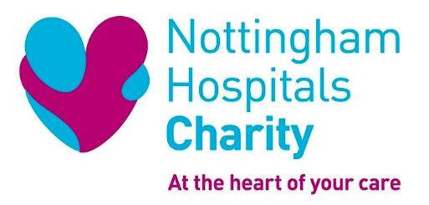

Role Description

Role Title: Supermarket Bucket Collector Volunteers

Reports to: Community Fundraising Team

Location: ASDA Supermarkets – Arnold (Friday) or Hyson Green (Saturday)

ROLE SUMMARY

We’re looking for friendly individuals who are happy to chat with people about the Charity and our aims, and encourage donations. This role will be a regular commitment for approximately 3 hours once per month, either on a Friday or a Saturday between 10am and 1pm.

Volunteers need to be confident, approachable, organised and enthusiastic. Experience in dealing with people of all ages and backgrounds is desirable, but if you are outgoing and easy to talk to you can learn while you volunteer.

As a Supermarket Bucket Collector, you will be helping to raise awareness of and contribute to our fundraising total of approximately £4 million pounds per year. All of which helps towards improving patient care at Nottingham’s Hospitals by funding medical research, purchasing state-of-the-art equipment, investing in staff development and improving facilities for patients and their families.

This role will take place at either the Hyson Green or Arnold branches of ASDA, once per month for 3 hours. You can choose which supermarket you go to.

KEY ROLE RESPONSIBILITIES

- Set up the table with Charity branded leaflets and merchandise.
- Talk to shoppers to raise awareness of the Charity and the fundraising activities they can get involved with
- Encourage donations through a bucket collection or signposting to a QR code.
- Record how many people you talked to and what the outcome was.
- Pack away the materials and return everything to the office.
- Represent the charity in a professional and friendly manner, in line with our values.

SKILLS AND EXPERIENCE

Previous experience is not necessary, as training will be provided, however this role would suit people that are:

- Friendly, approachable and organised
- Great at dealing with people in a polite and respectful manner
- Can commit to a regular time slot.
- Ability to work well with another team member
- Can travel to the supermarkets taking the necessary materials with them
- Passionate about supporting their local hospital and community

WHAT THIS OPPORTUNITY OFFERS YOU

- A regular volunteering opportunity
- A chance to meet some great people
- Increase your skills and gain valuable experience for your CV
- Make a difference to our hospitals by being part of the Charity

HOW WE WILL SUPPORT YOU

As a Supermarket Bucket Collector, we will support you with:

- Full volunteer induction
- Relevant training for the role
- Materials for the stall
- Charity branded clothing and an ID badge
- One to one support and regular catch ups with the Volunteer Development Manager or community fundraiser
- Out of pocket expenses in line with our policy
- A chance to gain the accredited National Volunteer Certificate.

WHEN IS THIS OPORTUNITY AVAILABLE?

Friday or Saturday, once per month, 10am – 1pm

HOW TO GET INVOLVED

For an informal chat or further information, please contact

Deb Morton, Volunteer Development Manager
email: deborah.morton@nuh.nhs.co.uk
telephone: 0115 9627905
mobile: 07812 279993
website: www.nottinghamhospitalscharity.org.uk

Please note: over 18s only.

