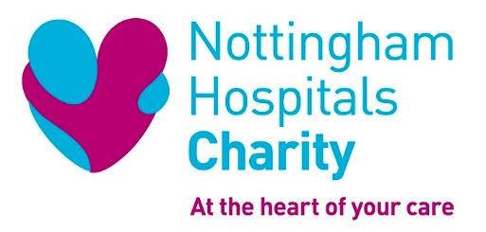

Role Description

Role Title: Hayward House Kiosk Volunteer

Location: Hayward House, City Hospital, Nottingham

ROLE SUMMARY

We’re looking for enthusiastic and friendly volunteers with great communication skills who are reliable, responsible, trustworthy and committed. Customer service and cash handling experience would be useful but is not essential as training will be provided.
Volunteers need to be confident and comfortable carrying out this role on their own and they also need to be sensitive to the location inside the hospice environment of Hayward House.

The Kiosk will be the face of our charity within Hayward House. It will sell small items of branded merchandise to promote the charity and raise funds. It will also act as a place for people to find out more about what we do and how we support the hospital by funding improvements for life-saving equipment, staff development, medical research and enhanced facilities. There is the opportunity for people to donate to the charity and sign up for our fundraising events.

As a Hayward House Kiosk Volunteer, you will be helping to raise funds through selling merchandise, and helping to raise the profile of Nottingham Hospitals Charity, our events and campaigns.

KEY ROLE RESPONSIBILITIES

- Setting up the Hub at the beginning of the session
- Greeting, serving and assisting customers
- Talking to patients, visitors and hospital staff about charity appeals, events and campaigns, to encourage support
- Distributing promotional materials and literature
- Recording sales and collecting donations
- Cash handling, including cashing up at the end of the day
- Monitoring stock
- Tidying up at the end of the session
- Undertaking training and skills development and to keep up to date with the change of requirements of the role

SKILLS AND EXPERIENCE

Previous experience is not necessary as full training will be provided, however this role would suit people that are:

- Friendly, polite and enthusiastic
- Organised and able to prioritise
- Good communicators with listening skills
- Reliable and honest
- Able to manage their time effectively
- Happy to handle cash and monitor stock
- Passionate about supporting their local hospital and community

WHAT THIS OPPORTUNITY OFFERS YOU

- Valuable experience for your CV, e.g
  - Customer service skills
  - Organisation and time management
  - Team working
  - Communication skills
- A chance to meet some great people
- Make a difference to our hospitals by being part of the Charity

HOW WE WILL SUPPORT YOU

As a Hayward House Kiosk volunteer, we will support you with:

- Full volunteer induction
- Relevant training
- Charity branded clothing and an ID badge
- One to one support and regular catch ups with a named person.
- A chance to gain the accredited National Volunteer Certificate.
- Pre-agreed travel expenses, and if you volunteer more than four hours a day, we offer lunch expenses too

WHEN IS THIS OPORTUNITY AVAILABLE?

The Hub aims to be open every weekday between 9am and 4pm, so this role would ideally suit someone looking to volunteer for a full morning or afternoon each week.
However, if you can offer at least 2 hours per week during these times we would love to hear from you.

HOW TO GET INVOLVED

For an informal chat or further information, please contact Deb Morton, Volunteer Development Manager, by emailing: deborah.morton@nuh.nhs.co.uk or telephone 0115 9627905

Please note: We are currently only able to involve volunteers aged 18 or over in this role.

