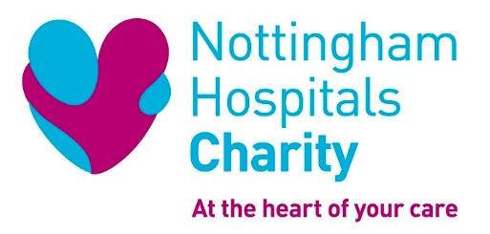

Events Volunteer Role Description

Role Title: Events Volunteer

Location: Various locations in the community

ROLE SUMMARY

We’re looking for people who are polite, friendly, and great at dealing with people to help support our fundraising events. This could mean helping us to setup events on the day, putting together goody bags, being part of our cheer squad, providing refreshments and stewarding attendees.

This opportunity would suit volunteers that are looking for a flexible opportunity that they can get involved in just a few times per year.

As an events volunteer you will be helping to make our events run as smoothly as possible and providing an extra boost to our fantastic fundraisers.

A few examples of events and what you could be doing:

QMC Abseil: Give out goody bags in the Charity tent after participants have abseiled 100 feet down the side of the Queens Medical Centre building.

Dragon Boat Race: Join us on the banks of the river Trent to cheer on the teams as they compete with each other for the fastest time.

Robin Hood Half Marathon: Provide runners with water bottles and encouragement as they complete the 13.1 mile course.

All these events help towards raising around £4million per year which goes towards improving patient care at Nottingham’s Hospitals. We fund medical research, purchase state-of-the-art equipment, invest in staff development and improve facilities for patients and their families.

SKILLS AND EXPERIENCE

Previous experience is not necessary as full training will be provided, however this role would suit people that are:

- Friendly and approachable
- Great at dealing with people in a polite and respectful manner
- Team players
- Able to follow instructions
- Passionate about supporting their local hospital and community

WHAT THIS OPPORTUNITY OFFERS YOU

- Flexibility to choose which events you are able to attend throughout the year.
- A fantastic way to meet lots of different people and get out and about in your community
- Valuable experience for your CV
- An opportunity to make a difference to our hospitals by being part of the Charity

HOW WE WILL SUPPORT YOU

As an Events volunteer, we will support you with:

- Full induction to our organisation
- Relevant training for the role
- Charity branded clothing
- One to one support and regular catch ups with the Volunteer Development Manager
- Out of pocket expenses in line with our policy
- A chance to gain the accredited National Volunteer Certificate.

WHEN IS THIS OPORTUNITY AVAILABLE?

As and when throughout the year. You will be contacted when we know how many people we need at an event and then you let us know if you are available. A lot of the bigger events are at weekends and some might last all day.

HOW TO GET INVOLVED

For an informal chat or further information, please contact

Deb Morton, Volunteer Development Manager
email: charity@nuh.nhs.co.uk
telephone: 0115 9627905
mobile: 07812 279993
website: www.nottinghamhospitalscharity.org.uk

Please note: Volunteers who are under 18 will need to be with a parent or guardian

