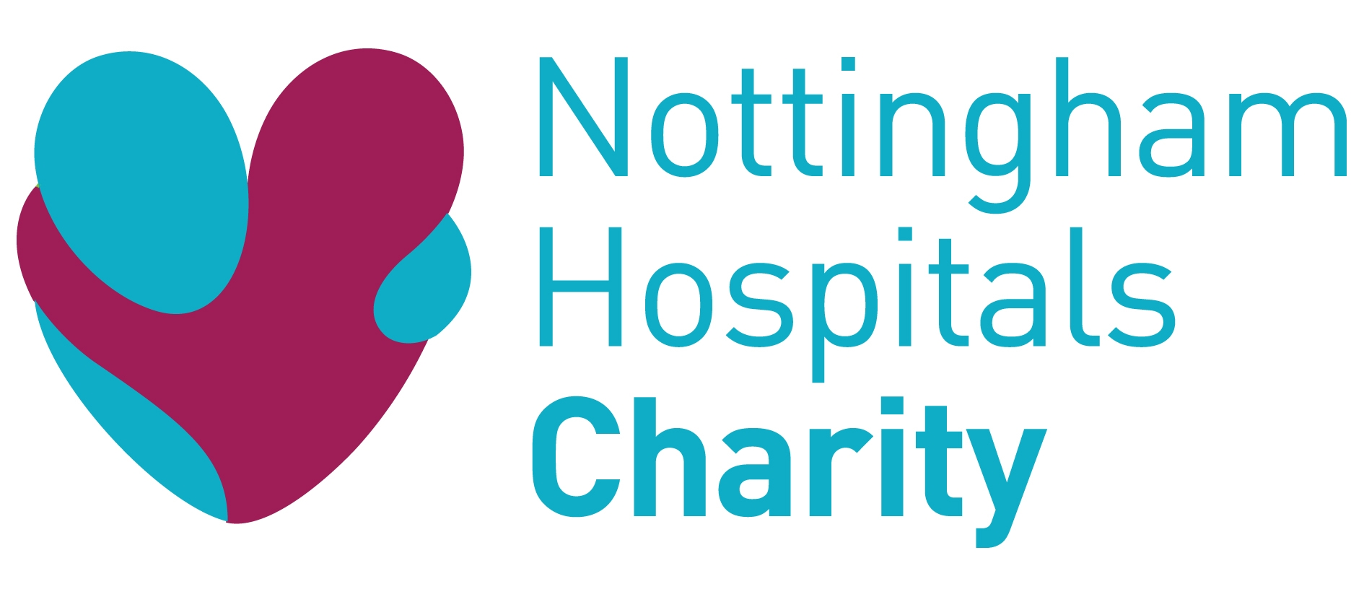

Job Description

Job Title: Community Fundraiser

Salary: £19,500 to £24,000 dependent on experience - pro-rata

Terms: Permanent, part-time – 22.5 hours per week

Reports to: Community Fundraising Manager

Location: Based at our City Hospital offices, with a requirement for the post holder to travel to the QMC campus as required. The Trust operates a shuttle bus for this purpose. We offer a flexible working policy.

JOB SUMMARY

Reporting to the Community Fundraising Manager, the post-holder will be responsible for developing income through effective donor acquisition; building and maintaining effective relationships and providing fundraising support and advice. You are the face of the charity in the community attending and organising events for our supporters.

KEY JOB RESPONSIBILITIES

- To implement a variety of fundraising initiatives to find new donors and to work with the Community Fundraising Manager to achieve income targets.

- To be a key contact for all community fundraising enquiries to the fundraising office including responding to telephone calls, emails and letters, collation and sending of information packs to potential and current supporters when necessary and to advise the general public and colleagues on queries relating to fundraising.

- Social Media:
- Use social media to engage, develop and steward fundraisers
- Update and post on social media platforms to enhance fundraising
- Identify fundraisers that are ideal candidates for case studies and social media
- Focus on promoting specific and targeted campaigns and appeals in line with the fundraising strategy

- To implement and run events in the community that raise both income and awareness whilst developing and engaging support for the charity.

- Update and liaise with the Communications team to ensure well-coordinated social and mainstream media activity

- To provide a high standard of donor care to community fundraisers, including but not limited to:
- Service clubs e.g. Rotary clubs, Lions, Masons
- Clubs and associations e.g. WIs, Brownies and other local groups
- Educational organisations e.g. schools, universities
- Small and medium sized companies.

- To utilise all fundraising techniques to encourage and motivate community and corporate fundraisers to maximise their fundraising potential.

- To develop and manage effective administrative processes to support relationship management.

- To develop and deliver talks and presentations to a variety of audiences.

- To work on specific projects as directed by the Community Fundraising Manager

- To conduct research on potential new opportunities for the Community Fundraising Manager to pursue.

- To work in our Charity Hub when required

- To support the Community Fundraising Manager with ad hoc activities.

- To attend cheque presentations within the hospitals and in the community.

- To support the facilitation and promotion of challenge events.

- To ensure the meticulous recording of all data relating to community and corporate fundraising on Raisers Edge and filing systems (including personal data and financial information).

- To be continually aware of the need for improvement and development of all aspects of advice and information to donors and colleagues

- To work within legal and charity guidelines.

- To work with NUH Charity’s fundraising, administrative and IT systems and guidelines.

- To represent NUH Charity internally and externally as required.

- To undertake training and skills development and to keep up to date with the change of requirements of the role.

- To undertake any other duties, which may be reasonably required.

- To regularly work outside of office hours.

Date July 2021

