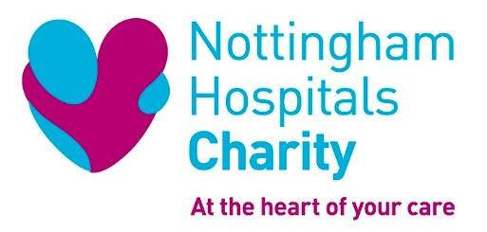

Role Description

Role Title: Charity Hub Volunteer

Reports to: Charity Hub Manager

Location: Queens Medical Centre, Nottingham

ROLE SUMMARY

We’re looking for enthusiastic and friendly volunteers with great communication skills who are reliable, responsible, trustworthy and committed. Customer service, cash handling or merchandising experience would be useful but is not essential as training will be provided.
Volunteers need to be confident and comfortable carrying out this role on their own, as there will not always be another member of the team present.

The Hub is the face of our charity within the hospital, and welcomes patients, visitors, staff and members of the public. It sells branded merchandise to promote the charity and raise funds. It also acts as a place for people to find out more about what we do and how we support the hospital by funding improvements for life-saving equipment, staff development, medical research and enhanced facilities. There is the opportunity for people to donate to the charity and sign up for our fundraising events.

As a Charity Hub Volunteer, you will be helping to raise funds through selling merchandise, and also helping to raise the profile of Nottingham Hospitals Charity, our events and campaigns.

The Hub is located near to the Main Entrance of Nottingham Queen’s Medical Centre.

KEY ROLE RESPONSIBILITIES

- Opening/ closing the Charity Hub
- Greeting, serving and assisting customers
- Processing sales through the till and card machine
- Cleaning the merchandise and shelving
- Basic administrative tasks including stock taking, stock replenishment and pricing
- Creating new and engaging displays
- Talking to patients, visitors and hospital staff about charity appeals, events and campaigns, to encourage support
- Distributing promotional materials and literature
- Cash handling, including cashing up at the end of the day
- To undertake training and skills development and to keep up to date with the change of requirements of the role

SKILLS AND EXPERIENCE

Previous experience is not necessary as full training will be provided, however this role would suit people that are:

- Friendly, polite and enthusiastic
- Organised and able to prioritise
- Good communicators with listening skills
- Reliable and honest
- Able to manage their time effectively
- Happy to operate a till and card machine, and handle cash
- Passionate about supporting their local hospital and community

WHAT THIS OPPORTUNITY OFFERS YOU

- Valuable experience for your CV, e.g
  - Customer service skills
  - Organisation and time management
  - Team working
  - Communication skills
- A chance to meet some great people
- Make a difference to our hospitals by being part of the Charity

HOW WE WILL SUPPORT YOU

As a Charity Hub volunteer, we will support you with:

- Full volunteer induction
- Relevant training
- Charity branded clothing and an ID badge
- One to one support and regular catch ups with Charity Hub Manager and/or the Volunteer Development Manager
- A chance to gain the accredited National Volunteer Certificate.
- Pre-agreed travel expenses, and if you volunteer more than four hours a day, we offer lunch expenses too

WHEN IS THIS OPORTUNITY AVAILABLE?

The Hub aims to be open every weekday between 9am and 4pm, so this role would ideally suit someone looking to volunteer for a full morning or afternoon each week.
However, if you can offer at least 2 hours per week during these times we would love to hear from you.

HOW TO GET INVOLVED

For an informal chat or further information, please contact Deb Morton, Volunteer Development Manager, by emailing: deborah.morton@nuh.nhs.co.uk or telephone 0115 9627905

Please note: We are currently only able to involve volunteers aged 18 or over in this role.

